Composition

📌 Definition:
# Source: AI Source: Provided by: [Data Path: Persons Table -> ID Column: 1, Name_En Column: Motasem Essam] -> From: [Chatgpt (GPT‑5 Mini)] on [12/9/2025]
Composition is a special type of association, which is a strong “has-a” relationship, where one object owns other objects, and those objects cannot exist independently of the parent.

🧠 Simple idea:
# Source: AI Source: Provided by: [Data Path: Persons Table -> ID Column: 1, Name_En Column: Motasem Essam] -> From: [Chatgpt (GPT‑5 Mini)] on [12/9/2025]
Composition = “strong ownership” 🧱
Whole → Parts (dependent)

🔍 Key characteristics:
# Source: AI Source: Provided by: [Data Path: Persons Table -> ID Column: 1, Name_En Column: Motasem Essam] -> From: [Chatgpt (GPT‑5 Mini)] on [12/9/2025]
- 🔗 Strong “has-a” relationship
- 🧩 Tight coupling between objects
- ❌ Child objects cannot exist without the parent
- ⚙️ Parent controls the lifecycle of the child

📌 Real-world examples:
# Source: AI Source: Provided by: [Data Path: Persons Table -> ID Column: 1, Name_En Column: Motasem Essam] -> From: [Chatgpt (GPT‑5 Mini)] on [12/9/2025]
- 🚗 Car → Engine
- 🏠 House → Rooms
- 👤 Human → Heart
- 📱 Smartphone → Battery
👉 If the Car is destroyed, the Engine also ceases to exist (in this model).

📌 Example (Java-style):
# Source: AI Source: Provided by: [Data Path: Persons Table -> ID Column: 1, Name_En Column: Motasem Essam] -> From: [Chatgpt (GPT‑5 Mini)] on [12/9/2025]
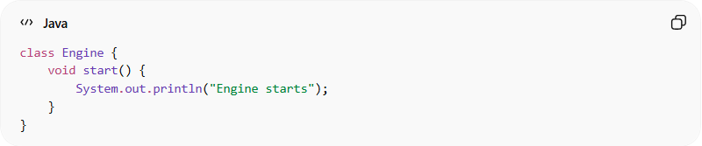
class Engine {
void start() {
System.out.println("Engine starts");
}
}
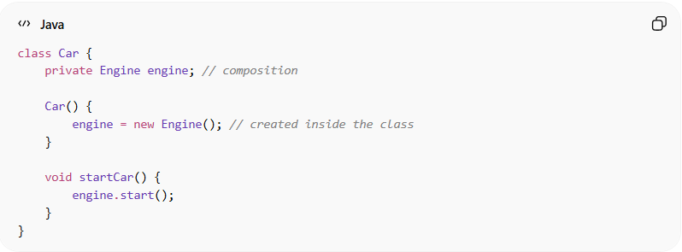
class Car {
private Engine engine; // composition

Car() {
engine = new Engine(); // created inside the class
}

void startCar() {
engine.start();
}
}

Usage:
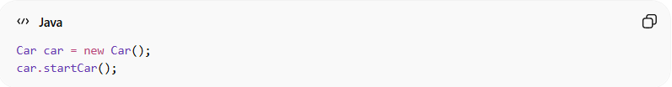
Car car = new Car();
car.startCar();
👉 The Engine is created and managed inside the Car.

🔄 Relationship diagram:
# Source: AI Source: Provided by: [Data Path: Persons Table -> ID Column: 1, Name_En Column: Motasem Essam] -> From: [Chatgpt (GPT‑5 Mini)] on [12/9/2025]
Car ◆────── Engine
(◆ represents composition — strong “part-of”)

🆚 Composition vs Aggregation:
# Source: AI Source: Provided by: [Data Path: Persons Table -> ID Column: 1, Name_En Column: Motasem Essam] -> From: [Chatgpt (GPT‑5 Mini)] on [12/9/2025]
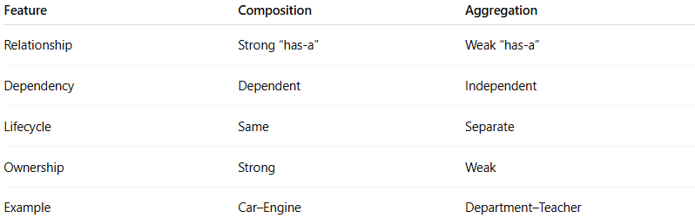
Feature | Composition | Aggregation
Relationship | Strong “has-a” | Weak “has-a”
Dependency | Dependent | Independent
Lifecycle | Same | Separate
Ownership | Strong | Weak
Example | Car–Engine | Department–Teacher

🎯 Why it is important:
# Source: AI Source: Provided by: [Data Path: Persons Table -> ID Column: 1, Name_En Column: Motasem Essam] -> From: [Chatgpt (GPT‑5 Mini)] on [12/9/2025]
- 🧩 Models strong real-world relationships
- 🔒 Ensures controlled object lifecycle
- ⚙️ Improves encapsulation
- 🧠 Helps design reliable systems

🎯 Summary:
# Source: AI Source: Provided by: [Data Path: Persons Table -> ID Column: 1, Name_En Column: Motasem Essam] -> From: [Chatgpt (GPT‑5 Mini)] on [12/9/2025]
Composition represents a strong “has-a” relationship where the child objects depend on the parent and cannot exist without it.

